Usages of Mainframe (server) computers in Wenzhou-Kean University

Sam Yan
Computer Science Deaprtment
Wenzhou-Kean University
Wenzhou, China
(+86)0-153-0687-0367
896298116@qq.com

ABSTRACT

As the development of Wenzhou-Kean University [4], departments require increasing amount of computing tasks. But factors such as the cost, policies and computability required by the departments also need to be taken into consideration. This research, comparing different devices vary from laptops to super computers of various kinds, intending to find the best devices for the usage of university department level computing.

Categories and Subject Descriptors

[Measurement]: This paper mainly measures 2 things:
- Computability required by university departments.
- Computability mainframes hold.

General Terms

[Measurement]: Measures the computability requirements and devices can provide.
[Design]: Design the solution according to the requirements of the departments.
[Human factors]: Policies that may influence the prices of the devices.

Keywords

[Super computers]: Computers that can compute at the speed of trillions or even quadrillions of times per second. [2]
[Mainframes]: Platforms that run operating systems and play computing tasks such as vitalization, networks, database and transactions. [5]
[Personal Computers (PCs)]: Devices that exist ubiquitously for personal usages. [4]
[Price]: The cost spent (in RMB) to purchase a certain device or devices is called the price of that device.
[CPU]: Central processing unit consists of arithmetic/logic unit (ALU), control unit (CU) and memory.[1]
[Computability]: Number of instructions a computer can deal with in one second, denoted as MIPS (million instructions per second). [3]
[Energy consumption]: Amount of electricity consumed for running a certain device.

INTRODUCTION

In years 2015-2020, as mentioned earlier, the university needs more computing tasks. These computing tasks come from all the departments that uses the server of our university. And as the IT department staff Wei Guocheng mentioned, till now, already about 80% of the servers are busy. In the future, the university library need servers to increase their database to hold increased digital books and user information because part of the library database will open to the customers overall the citizens who have access. Science departments, especially computer science department, need servers to study client-server programming, scientific computing and parallel computing. The amount of servers required by the university in the near future seems quite large. [6]
This research will mainly focus on following things:
(1) How does the server / mainframes work?
(2) What are the advantages of servers / mainframes compare to the PCs or even the combination of PCs?
(3) Why the university need servers?
(4) What factors do we need to take into consideration when choosing the servers?
(5) What kind of server does the university need?

Literature Review

How is client-server model work
Mainframes or servers that plays computing tasks mainly use client-server model. Client means devices who requires a task to be done without caring how it is finished. Servers get the tasks required by the clients and deals with them through a certain procedure. Clients are connected to servers through Transmission Control Protocol (TCP) or User Datagram Protocol (UDP). TCP, which is a higher level of transmission, transfers I/O streams through client and servers. UDP transfers packets through servers and clients. To access a server, you have to know the server’s IP address and the port you would like the server to listen to. Client-server models can be played in multi-threading procedures. [7] One affect of running client server model is that the programs will take up cache memory obviously, as shown in data collection section.

What factors do we need to take into consideration of server machines
The main factor that influences the use of mainframe is the cost. Broadly speaking, a server ranges from 20, 000 to 100, 000 RMB, while a laptop / PC only costs less than 10,000.
According to Headmaster Office of Wenzhou-Kean, purchases more than 50,000 needs to go through a special procedure and to be proved by the metropolitan government’s financial office, so cost influences the procedures and policies, resulting in political factors become an issue of buying servers.
As the paper Energy Analysis of Parallel Scientific Kernels on Multiple GPUs stated that the use of just one GPU will cause more power-consumption than using 24 CPUs. But the use of GPU will significantly improve the computability of the devices, so the derivation of per unit of energy cost for computing various from cases to cases and worth consideration. Thus, energy consumption is also one of a major factor that needs to be taken into consideration.
Due to the factors listed above, the most important factor is the usage of the servers. According to the interviews with Dr.Zhang, a computer professor of Wenzhou-Kean computer science department, 4 servers needs to be bought for doing scientific computing and simulations, while another 4 are needed to execute parallel computing running the applications written in the parallel computing and advanced algorithms classes. Wenzhou-Kean strategic plan also mentions the enlarge of the library, requiring more servers to hold new books and visitors’ account information. To conclude, the purpose of servers is a major factor that need to be taken into consideration.

Study Design

This research will first go through literature review to find how the server-client model works, and what kind of issues need to be taken into consideration when buying servers.
Then it will collect some data of the computability requirements by the university at now and in 3 years. It will also gather the data of personal computers, server machines and super computers to see whether it is proper for the university to own server machines.
To finish, the research will give a deep data analysis and give some recommendation on the usage of servers in the specific situation of Wenzhou-Kean campus for people to refer to it.

Data Collection

On analyzing the requirements of the mainframe machines need by the university, it is essential to know the computability the university requires now. This research get the data of the conditions of the running condition of servers in Wenzhou-Kean on a particular month (from 27th, March to 23rd, April, 2015). As shown below:

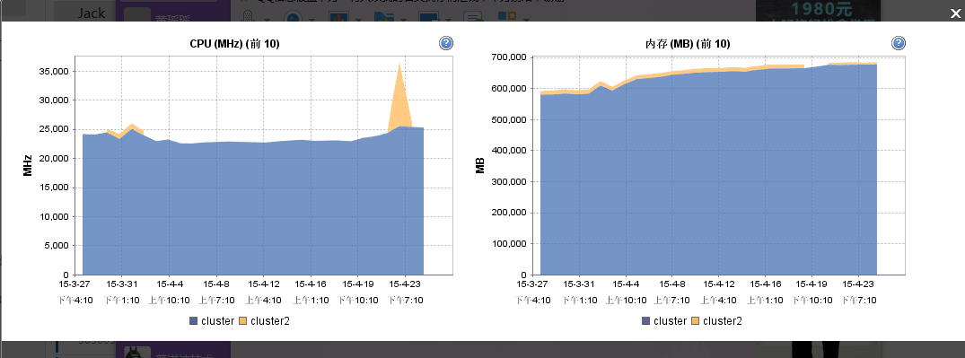

Picture1: The usage of CPU and Memory of Wenzhou-Kean’s cluster system.

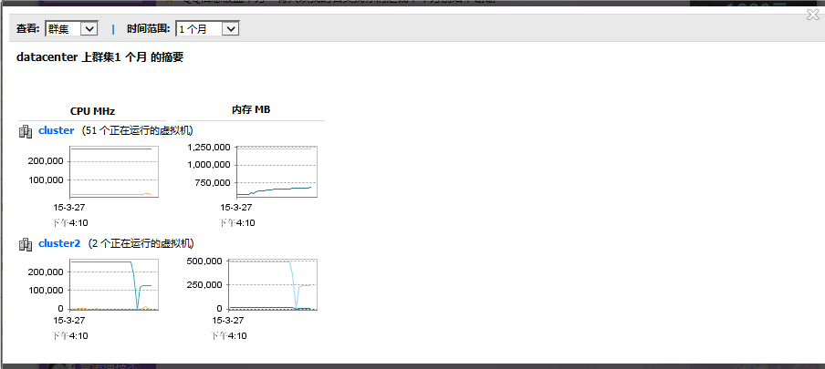

Picture2: The increasing memory use and the unstable of the back-up server.

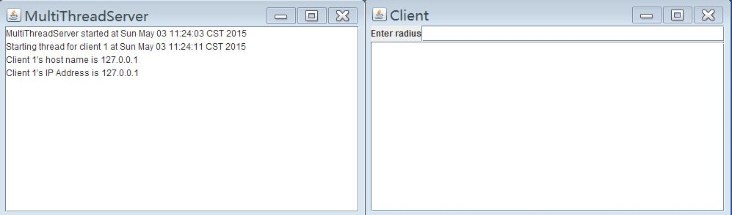

Picture3: One easy program of client-server model:

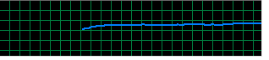
Picture4: The use of physical memory when the client-server model starts.

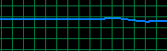

Picture 5: The use of physical memory when the client-server model halts.

Next, the research will use a table to compare PCs (using laptop computer ASUS FX50JK4200 14 inches), servers (Waving Tide NF5280M3) and super computers (Milky way-2), as shown below:

 | ASUS Laptop | Waving Tide Mainframe | Milky way-2
System | Windows 8.1 | Windows 2008 Server | Kylin Linux
CPU Name | Intel HM86 Core i5 | Intel 5520 + ICH10R | Intel Xeon E5-2692v2 12C
CPU Frequency | 2.8 GHz, overclock 3.4 GHz | 2.13 GHz | 2.2GHz
Maximum CPU Numbers | 1 | 2 | 3120000
Bus | 5 GT/s | 4.8 GT/s | N / A, performance
Level-3 Buffer | 3 MB | 8 MB | N / A, performance
CPU Core Numbers | 2 | 4 | N / A, performance
CPU Threads | 4 | 4 | N / A, performance
CPU Size | 22 nm | 32 nm | 22 nm
Calculating Speed | 2 * 2.8 G  Flop / s | 150.3 G  Flop / s [10] | 33,862.7 T Flop/s
Maximum Access Memory | 12 GB | 144 GB | 1024000 GB
Type of memory | DDR3 | DDR3 | N/A
Net Devices | Wireless card + 1 *  1000 Mbps Ethernet card | 2 * 1000 Mbps card | N/A
Interfaces | 1 * USB2.0 + 2 * USB3.0 + VGA / Mini D-Sub + RJ 45 + Power | 2 * RJ45 + 4 * USB + 1 * VGA + 1 * Serial ports + Mouse / Keyboard interface | N/A
Power | 220V, 90W | 110-240V, 600W | 17808 KW
Price* (RMB) | 5550 | 48050 | 3 billion
*Price is calculated as the mean of lowest price and the highest price. [8] [9]

Data Analysis

From the data showing the usage of the main cluster sever in Picture1 in the data, it can be concluded that the CPU use of the whole cluster machines stays stable in generall (24,000 GHz). But these CPUs may over-clock during 3-4 days in a month (up to 36,000 GHz). The memory required by the university shows the tendency of increasing steadily.
On observing the CPU physical memory (actually the cache memory) use through the starting periods or ending periods of the client-server model, it can be concluded that client-server model takes up cache memory obviously because the start of only one thread of the whole server-client program sees the dramatic increase of the cache use. With the thread numbers increasing (in real situation means the number of clients ask for service increased), the physical memory will be taken up more. It is not difficult to discover the similarity of the 4th picture and the right one of the 1st picture. This experiment thus can reflect the situation that with the develop of the university and more and more departments need computing tasks (departments are view as clients), how the “physical memory” of the server machine will change. It can be seen that if the university continues to develop and more computing tasks are needed, the server will soon suffer physical memory overflow.
From the analysis above, we can see a major factor that influence of computability is the memory. The next analysis focus on the table comparing PC, servers and super computers. First, due to the sky-high price of a super computer, it automatically becomes out of our expectation. By spending 8.7 times the money as buying a laptop, buying a mainframe can give users 12 times the memory, which is cheap. Another benefit of buying a server is that the consume of electricity is lower. Because 8 laptops together will at least consume 720w of electricity, while a server only consume 600w. But the actual calculating speed does not change too much. Suppose that through n frequencies CPU can deal with one instruction. The ASUS laptop with 2 cores needs N / 5.6 shares of time to finish the task, while the server needs N / 8.52 shares of time. The speed of the server is just 1.5 times as a laptop. Also, even if the server has 2 * 1000 Mbps ethernet cards, the prices does not cover the expectation.
Buying an mainframe is not only benefit in the memory, but it also benefits in the calculating speed. According to the table comparing the calculating speed (in Flop per second), the Waving Tide mainframe computes at 150.3 G Flop / s while the ASUS computer only computes at 5.6 G Flop / s. The mainframe computes about 26.8 times as quick as the ASUS laptop computer while the price is only about 8.66 times. This static shows if servers are bought mainly for computing, it may be a much better choice than buying the correspond number of laptops.
However, this research omits the cases of buying super computers for these devices cost buyers billions of RMB, which is really an broaden even for the metropolitan government considering the economy situation of Wenzhou. Also, in the future 5 years the university does not need such a large computability. Buying a super computer is to some extends a waste. So super computers are automatically out of our expectations.

Recommendation

On comparing the computing task requirements and the efficiency of cost for laptops, mainframe servers and supercomputers, it is found out buying mainframe machines is the most cost-effective choice compared to buying clusters of laptop or PCs, or simply buy and build a super computer.
Due to the usages of servers for computer science department, which requires to use servers to do simulation, scientific computing and parallel computing most by professors and inexperienced students who may still under training, so the second suggestion is that the university needs to consider the probability that severs got crashed. Thus, it may be a better choice to buy servers more than required numbers with a little lower abilities. (Ranging from 20,000 to 50,000 each usually)
But due to the usages of servers in the library, which requires storing data and process readers’ needs, servers needs to own higher computability, better with GPUs in. And situations such as disaster recovery needs to be considered.
About GPUs, based on the use of the needed mainframe, which is used mainly for parallel computing and scientific computing study for computer science major and the data storage, checking and modifying for the library, actually a certain number of GPUs are needed to be embedded into the servers to increase the computability. But the mainly recommendation is to remain most part of them just CPUs for saving energy for the scaling of computing tasks needed is still limited as me.

Problems and limitations

- On mentioning the cost, the research does not pay attention to the maintenance of the servers. By adding RAMs into it, by changing the hard disk in it or even by simply clean the servers, money and time need to be taken into consideration.
- The research only choose several particular models representing a specific type of computing facilities, which may be biased. The right decision should be sampling from a big number of facilities from laptops, servers and super-computers and then compare the mean of their functions. Due to time limited, this remains to be a good future research topic.
- This is a research only conducted in Wenzhou-Kean due to time and location factors, the results may be different why applied to other universities or departments.
- Due to researcher’s time and knowledge limitation, the research may be biased in some of the parts.

Conclusion and declaration

This research starts with the recent situation of making a decision whether a sever should be purchased in the university, through comparing the computability with cost, energy, memory and speed efficiency of laptops, servers and supercomputers, analyzing the data of the comparisons and ends up with talking about recommendations for using these computational devices properly in the situation of several certain departments relevant to the usage of servers.
The goal of this research is trying to figure out the most cost-efficient way to satisfy the needs of computing tasks by the computer department and the library, figuring out that using server may be a good choice.
On buying the servers, we recommended that the usages of servers need to be carefully considered for the factors such as server-crash, meeting a disaster will obviously influence the use of servers.
Finally, it is up to the related departments to decided the use of servers due to their recent situation. This research just put-forward data, analysis and recommendations. The researcher has no responsibility for any results due to listening and taking the whole or partially ideas from this research and take them into real execution. But the researcher strongly welcome readers to discuss the limitations of the research and readers own ideas related to such a situation and thank for the readers who read this research. The researcher will especially appreciate those who discuss the ideas of server use in a situation like a department or a university with him.

REFERENCES

- Irv Englander, The Architechture of computer hardware, system software, and networking, international student version, in Wiley, 2010, ISBN: 987-0-470-40028-9, p.g.200,
- Top500 super computer lists: URL:http://www.top500.org/lists/2014/11/
- Kuen-Huei Lin; Yuan-Lung Li; Yufu Yeh; Chung-Yang Huang, QuteVP: A multi-million-instructions-per-second virtual platform for SoC hardware/software co-design, in Communications, Circuits and Systems, 2009. ICCCAS 2009. International
- Sahni, S.; Boustani, A.; Gutowski, T.G.; Graves, S.C.,Reusing personal computer devices - good or bad for the environment?, in Sustainable Systems and Technology (ISSST), 2010 IEEE International Symposium on Sahni, S.; Boustani, A.; Gutowski, T.G.; Graves, S.C., IEEE, 17-19 May 2010
- Qingjian Ni, Education and Learning Research in Foundation Courses of Mainframe, in Computational and Information Sciences (ICCIS), 2013 Fifth International Conference, 21-23 June 2013
- Wenzhou-Kean University Strategic Plan 2015-2020
- Introduction to Java Programming, Y.Daniel Liang, in Person, 2013, 9th edition, p.g.1155-1196
- ZOL Online sell, URL: http://detail.zol.com.cn/series/16/14993_1.html
- Top 500 the list, URL: http://www.top500.org/system/177999
- Zhang Guilin, Waving Tide NF2580, URL: http://server.zol.com.cn/206/2061952.html

